Implementation of Depth First Search (DFS) Using Python
Aim
To traverse a graph using the Depth First Search (DFS) technique.
Objective
- To visit all nodes in a graph.
- To explore nodes deeply before backtracking.
- To avoid revisiting nodes.
- To understand graph traversal.
- To display the DFS traversal order.
Algorithm
- Start the program.
- Create a graph.
- Select a starting node.
- Mark the node as visited.
- Display the node.
- Visit each unvisited adjacent node recursively.
- Repeat until all nodes are visited.
- Stop the program.
Program
graph = {
'A': ['B', 'C'],
'B': ['D', 'E'],
'C': ['F'],
'D': [],
'E': [],
'F': []
}

visited = set()

def dfs(node):
if node not in visited:
print(node, end=" ")
visited.add(node)

for neighbor in graph[node]:
dfs(neighbor)

dfs('A')

OUTPUT:
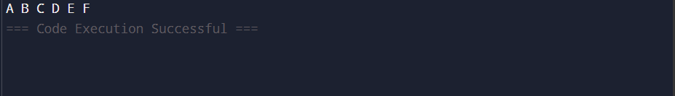

FLOW CHART:

Result
Thus, the graph was successfully traversed using Depth First Search (DFS)

